CHAPTER 1
BACKGROUND OF THE STUDY
Don Macchiatos was founded in October 2022 in Cebu by Nickie "Nic-nic" San Juan and her partner, Ariel Alegado. It has built a growing presence in City of Koronadal, where it has become a popular choice for affordable and convenient coffee. In City of Koronadal, Don Macchiatos outlets are often located near Koronadal National Comprehensive High School (KNCHS), making them easy to reach for customers on the go. Known for its signature macchiato, the brand attracts many students, office workers, and local residents who are looking for a quick and budget-friendly drink. Its accessible pricing and consistent taste have helped it gain strong support within the local community. The simple take-out concept and fast service fit well with the lifestyle of people in the city, especially those who prefer quick refreshments during breaks or while commuting, and this convenience has contributed to its steady growth in the area.

ADMIN DEPARTMENT
In the rapidly evolving coffee industry, Don Macchiatos has carved out a significant niche by prioritizing accessibility, yet the Admin department continues to face operational bottlenecks due to a heavy reliance on manual processes for daily business activities. Currently, essential tasks ranging from inventory tracking and staff scheduling to financial reporting and supply chain coordination are documented and executed through physical ledgers or fragmented manual systems, which increases the risk of human error and slows down decision-making. This study explores the impact of these manual workflows on the overall efficiency of the management tier, highlighting how the lack of a centralized digital system hinders the Admin's ability to maintain consistency across multiple branches and respond swiftly to market shifts. By examining the current "pen-and-paper" or manual entry culture within the leadership department, this research aims to identify specific pain points in the operational pipeline and establish a foundation for transitioning toward more streamlined, automated management solutions that align with the brand’s expansive growth.

INVENTORY DEPARTMENT
The inventory management of Don Macchiatos in the City of Koronadal currently relies on a manual recording system, where daily stock movements and ingredient usage are tracked through physical ledgers and handwritten logs. While this traditional method provides a direct paper trail of the branch's high-volume sales, it presents significant challenges in maintaining real-time accuracy and responsiveness to the fluctuating demands of the local market. As the outlet strives to maintain its reputation for consistent quality and affordability, the reliance on manual entries increases the risk of human error, delayed reporting, and potential discrepancies in raw material levels. Consequently, this study examines the impact of manual inventory practices on operational efficiency, focusing on how these traditional workflows influence waste management and the overall ability of the department to support sustainable business growth in a competitive urban landscape.

PRODUCTION DEPARTMENT
The flow of resources from the Inventory Department to the Production Department at Don Macchiatos is currently governed by a manual recording system, where the transfer of raw coffee beans, syrups, and dairy products is documented through handwritten requisition slips and logbooks. This traditional handover process requires meticulous coordination to ensure that the production line remains stocked for high-volume periods, yet the lack of automated synchronization often leads to information silos and time-consuming physical reconciliations. Because manual tracking is susceptible to transcription errors and delayed updates, there is a critical need to examine how these paper-based internal controls affect the speed of beverage preparation and the accuracy of usage reporting. This study aims to analyze the efficiency of manual inter-departmental documentation, identifying how these traditional workflows impact the seamless transition of materials from storage to the final product in a fast-paced retail environment.

SALES DEPARTMENT
The operational workflow of Don Macchiatos in the City of Koronadal relies on a continuous manual recording chain, where the movement of resources from the initial release by the Inventory Department to the beverage preparation in the Production Department, and finally to the point of transaction in the Sales Department is documented through handwritten logs and physical tallies. This paper-based system requires rigorous coordination to ensure that raw material usage aligns with the volume of coffee sold, yet the lack of automated synchronization often leads to discrepancies during end-of-day reconciliations. As the branch manages high daily foot traffic in a competitive local market, the reliance on manual entries across these three critical departments increases the risk of human error, delayed reporting, and potential stock imbalances. Consequently, this study examines the efficiency of manual inter-departmental documentation, focusing on how these traditional internal controls impact the accuracy of financial reporting, waste management, and the overall ability of the business to maintain its promise of affordable, high-quality service.

ACCOUNTING DEPARTMENT
The operational framework of Don Macchiatos relies on a traditional, manual flow of information where sales data from daily point-of-sale transactions to inventory usage is physically recorded and then manually transitioned to the accounting department for reconciliation. This hand-off process creates a critical dependency on paper-based documentation, which often leads to time-consuming data entry, a higher probability of human error during transcription, and significant delays in generating real-time financial statements. Within this manual ecosystem, the lack of an integrated digital bridge between sales and accounting hinders the business's ability to quickly track profit margins, manage stock levels across multiple branches, and ensure immediate fiscal transparency. This study examines how these manual hand-offs impact the overall efficiency of Don Macchiatos, focusing on the systemic risks of data fragmentation and the growing necessity for a unified automated system to synchronize sales performance with accounting accuracy.

MARKETING DEPARTMENT
The Marketing Department at Don Macchiatos in the City of Koronadal operates at the final stage of a traditional data chain that begins with the Inventory Department and moves sequentially through Production and Sales. In this manual workflow, the development of marketing strategies is heavily dependent on data extracted from handwritten stock ledgers, physical production tallies, and manual sales invoices. Because this operational information is recorded and consolidated without digital integration, the Marketing Department frequently encounters significant delays and inaccuracies when attempting to identify high-demand products or peak customer hours to design timely promotions. This study investigates the challenges of crafting competitive marketing campaigns in a fast-paced urban market when the foundational data—from raw material availability to final transaction records—is fragmented across multiple manual checkpoints, ultimately aiming to determine how these labor-intensive internal processes influence the brand's market positioning and promotional agility.

GAPS ANALYSIS
Transitioning Don Macchiatos from manual paperwork to an automated system bridges a critical operational gap by replacing labor-intensive tasks with real-time digital precision. Manual operations currently consume 40% to 60% of administrative time, but a systematic digital infrastructure slashes this burden to just 5% to 10% (Nwankwo & Akinola, 2020).
These automated systems operate approximately 40% to 50% faster than manual methods by eliminating the "manual lag" of handwritten notes (Bagad, 2021).
The shift is Specific in focus and Measurable through a 25% increase in accuracy, making it Achievable to reclaim half of a manager's daily productivity (Peluso, 2023).
Ultimately, this Relevant development ensures competitive service speeds and provides Time-bound efficiency gains within the first month of deployment.

CHAPTER 2
OLD FLOWCHART
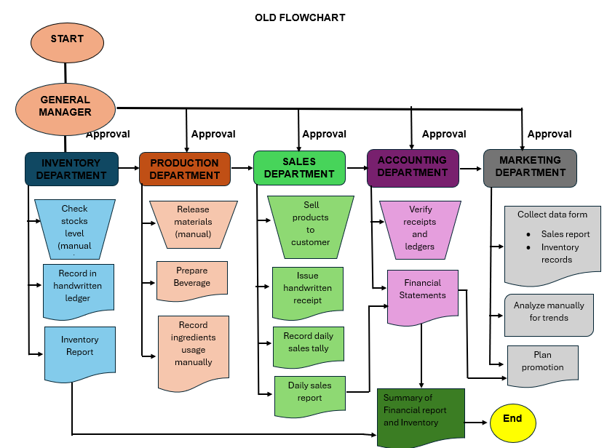

NEW FLOWCHART
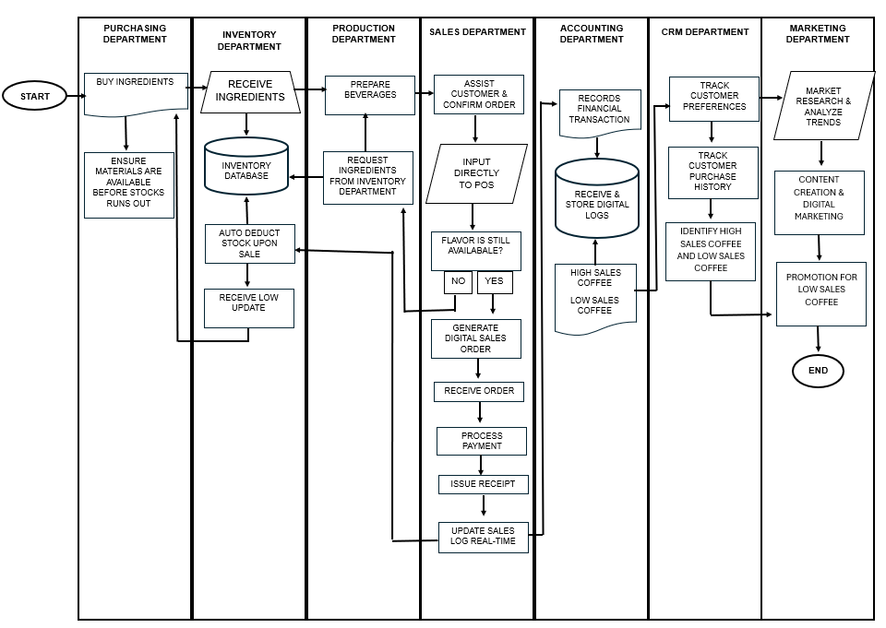
The process starts with the Purchasing Department, which is responsible for obtaining all raw materials and supplies needed for daily business operations. This includes ingredients such as coffee beans, milk, sugar, syrups, flavorings, cups, lids, straws, napkins, and other packaging materials. The department regularly checks stock requests coming from the Inventory Department and purchases new supplies before current stocks are depleted. It also compares suppliers based on price, quality, and delivery speed to ensure cost efficiency and consistent product standards. By maintaining a stable supply chain, the Purchasing Department prevents shortages that could delay production or reduce customer satisfaction.
After materials are purchased, they are transferred to the Inventory Department. This department receives all incoming ingredients, checks their quantity and quality, and records them into the inventory database. It is responsible for organizing storage areas and ensuring that products are stored properly based on safety and freshness requirements. The Inventory Department continuously monitors stock levels through the system and automatically deducts quantities whenever sales are made or ingredients are used in production. It also generates low-stock alerts when materials are running out, allowing the Purchasing Department to reorder supplies immediately. Accurate inventory control helps reduce waste, prevent overstocking, and maintain smooth operations.
Once ingredients are available, the Production Department begins preparing beverages based on customer orders. This department requests the necessary ingredients from inventory, such as coffee beans, milk, or syrups, and uses them to create drinks according to standard recipes. Staff members ensure that beverages are prepared quickly, correctly, and with consistent taste and quality. They also update the system regarding ingredient usage so inventory records remain accurate. If certain ingredients are unavailable, the department coordinates with inventory or sales staff to offer alternatives. The Production Department plays a key role in customer satisfaction because product quality and preparation speed directly affect the customer experience.
The next stage is handled by the Sales Department, which directly interacts with customers and manages all order transactions. Employees assist customers in selecting products, confirming orders, and entering details into the Point of Sale (POS) system. The system checks whether the selected flavor or item is still available in stock. If available, a digital sales order is generated and sent to the Production Department. Afterward, the department receives payment through cash, card, or digital methods, issues receipts, and updates the sales log in real time. Every completed sale automatically reduces stock levels in the inventory system. The Sales Department is essential because it connects customers, production, and inventory while ensuring smooth and accurate transactions.
The remaining departments focus on analysis, finance, customer relationships, and business growth. The Accounting Department records all financial transactions, stores digital logs, tracks expenses and revenues, and identifies products with high or low sales performance. This helps management evaluate profitability and control costs. The CRM Department tracks customer preferences, favorite drinks, frequency of visits, and purchase history. This information allows the company to personalize services, improve loyalty programs, and build stronger customer relationships. Finally, the Marketing Department uses sales and customer data to conduct market research, analyze trends, create promotional content, and run digital marketing campaigns. It especially promotes low-selling products to increase demand. Together, these departments help the business improve decision-making, customer satisfaction, and long-term profitability
DEFINITION OF TERMS
Agility - is the ability of an organization to rapidly adapt to market changes, internal shifts, and customer demands without losing momentum or quality.
Budget-friendly - refers to an item or service that is reasonably priced and offers good value without causing financial strain or exceeding one's set spending limit.
CMR (Customer Relationship Management) - is a technology and strategy used by businesses to manage, analyze, and improve interactions with customers and prospects throughout the entire lifecycle to drive sales growth and retention.
Fragmented - describes something that has been broken into small, separate, or disconnected parts rather than existing as a complete and unified whole.
Macchiatos - is an espresso-based coffee drink that is "marked" or "stained," typically referring to a shot of espresso topped with a small dollop of frothed milk or, in some variations, steamed milk marked with a shot of espresso.
Meticulous - describes a person or process that shows extreme care, precision, and thorough attention to even the smallest details.
Reconciliations - are the accounting processes used to compare two sets of records such as a bank statement and a general ledger to ensure that the figures are in agreement and to identify any discrepancies that require correction.
Refreshments - refer to light snacks and drinks provided in a social or professional setting to renew energy and provide comfort to participants.
Rigorous - describes a process or standard that is extremely thorough, exhaustive, and strictly applied to ensure total accuracy and adherence to rules.
Silos - refer to isolated departments or teams that operate independently and fail to share information or goals with other parts of the same organization.
SMEs (Small-to-medium Enterprises) - are independent businesses that fall below certain limits regarding employee count, assets, or annual turnover, playing a vital role in economic growth and innovation.
Synchronization - is the process of coordinating multiple parts of a system or different sets of data so that they operate in unison or maintain identical, up-to-date information at the same time.

SIGNIFICANCE OF THE STUDY
The significance of this study lies in its potential to identify the operational impacts of manual systems on a rapidly growing enterprise in the coffee industry. By examining the current workflows at Don Macchiatos in the City of Koronadal, this research provides valuable insights for the following stakeholders:
​To the Business Owner/Management: The study highlights the specific bottlenecks and risks associated with manual recording such as human error and data fragmentation allowing for more informed decisions regarding future digital transitions, internal controls, and resource allocation.
​To the Department Heads (Inventory, Production, Sales, Accounting): It serves as a diagnostic tool to understand how inter-departmental communication can be improved. It provides a clearer picture of how manual handovers between storage, the kitchen, and the counter affect overall service speed and product consistency.
​​To the Employees: By identifying the labor-intensive nature of manual logging, the study advocates for more streamlined workflows that could eventually reduce the administrative burden on front-line staff, allowing them to focus more on product quality and customer service.
​To Future Researchers and Accounting Information System Students: This study contributes to the body of knowledge regarding the scalability of manual systems in small-to-medium enterprises (SMEs). It provides a practical reference for those studying management information systems, internal auditing, and operational efficiency within the local food and beverage sector.

